Registering on TII Road Safety Audit Approvals System (RSAAS) website https://web.nra.ie/safetyaudits/

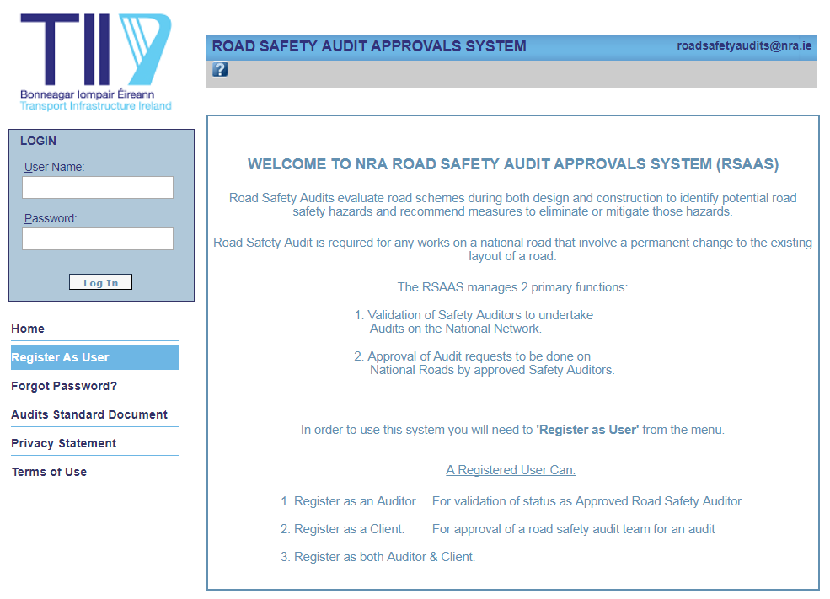
First step is to register as a user and get a password sent back to you.

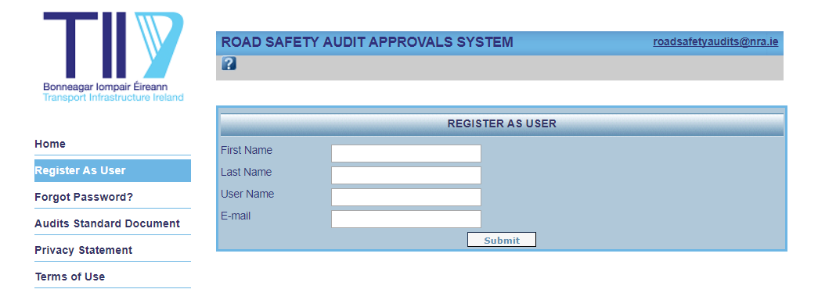
Next step is to register as either, or both, of the following:-
- Client. This is for individuals acting for a Local Authority, Engineering Consultant, Architect or Developer, or individual householders who are applying for approval for the Road Safety Audit Team for a specific Scheme.
An individual who is in the proposed Audit Team for a particular scheme cannot act as a Client for that scheme.
The definition of a Road Scheme and the requirements for approval are given in GE-STY-01024 Road Safety Audit http://www.tiipublications.ie/library/GE-STY-01024-07.pdf.

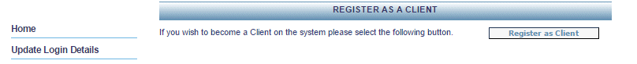

- Auditor. This is for engineers who wish to register as road safety auditors.
The auditor’s qualifications and experience in road safety audit are entered and the auditor is registered on the system as either Team Member or Team Leader for each Scheme Category in accordance with TII requirements.
The requirements are detailed in GE-STY-01025 - NRA HD 19 Road Safety Audit - Audit Team Qualifications http://www.tiipublications.ie/library/GE-STY-01025-01.pdf.

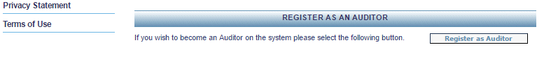

Registering as a Client
Client Type: If you are an individual acting for yourself choose the “Private Citizen” option, and then enter your address and contact details.
All other individuals should enter company or local authority name, position, address and other contact details. Several company names are already entered and can be picked from a dropdown list. If your company is not on the list it can be added using the “Add Company” button.
If one company has several different branches then each branch should be entered separately with the correct postal address for each branch, and with an amended company name using some unique identifier such as its location or specialisation.
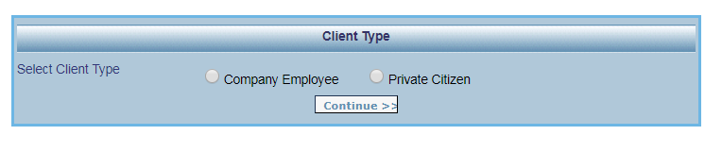

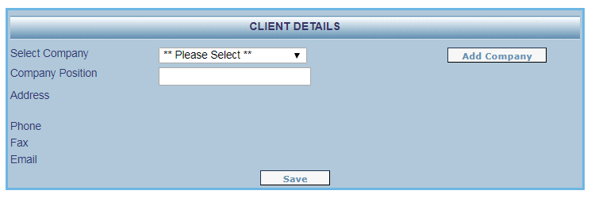

Registering as an Auditor
Company: Enter your company or local authority name and your position. Several company names are already entered and can be picked from a dropdown list. If your company is not on the list it can be added using the “Add Company” button.
If one company has several different branches then each branch should be entered separately with the correct postal address for each branch, and with an amended company name using some unique identifier such as its location or specialisation.

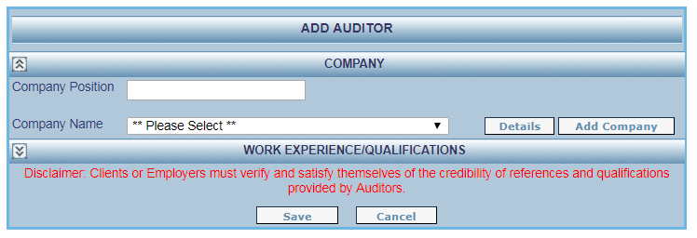

Work Experience /Qualifications:
Enter the date completed of your Road Safety Audit (3-5 day) Course. If you have a certificate for this course then a scan of this should be uploaded via the “Documents” section below. Attendance at this course is required for all registered auditors.
Enter the date completed of your Certificate of Competence Course. If you have a certificate for this course then a scan of this should be uploaded via the “Documents” section below. All registered Team Leaders are required to have a Certificate of Competence.
Indicate whether you are a Chartered Engineer, or an equivalent in another relevant profession.
Other relevant qualifications may also be entered.
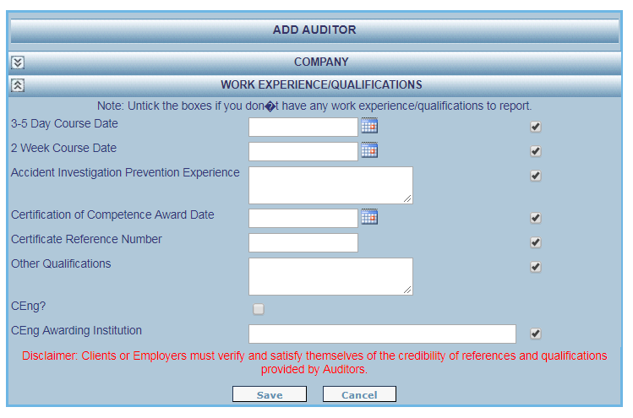

Work History: It is not necessary to enter your entire history of audits in this section, only sufficient to qualify as an auditor under the current TII requirements. Refer to GE-STY-01025 - NRA HD 19 Road Safety Audit - Audit Team Qualifications.
At least 5 audits must be entered into this section in order to qualify as a Team Member; at least 10 audits are required to qualify as a Team Leader.
An auditor needs experience of at least two audits as team member on a particular Scheme Category in order to be a Team Leader for an audit on that Scheme Category. Ensure that your list of audits covers this if you are looking for Team Leader status.
An auditor needs to have done audits recently in order to qualify as Team Leader. Ensure that your list includes your most recent audits.
After initial submission and registration it is possible to add further audits to the work history, or to add qualifications to the “Work Experience /Qualifications” section, and resubmit. An auditor’s Team Leader status can thus be updated at any time.
All audits that are approved through the RSAAS will automatically be added to your audit history through the “NRA Audit history” section. It is not necessary for you to add these to the “Work History” section.
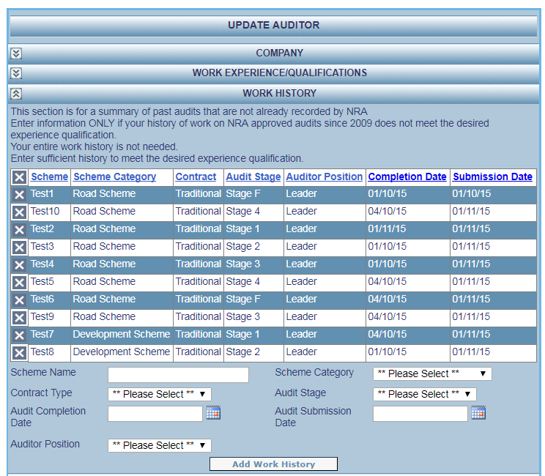

Documents: Use this section to upload documents to the system. All reports of the audits listed in the “Work History” section should be uploaded, as should certificates for courses attended.
Both .doc and .pdf files are accepted, and the maximum document size is 5MB.
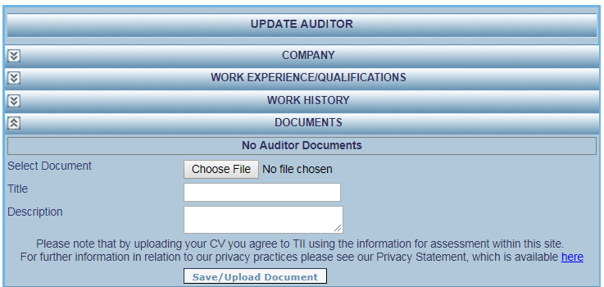

Submission: Submit using the “Submit for Approval” button. For all submissions after the initial one choose the reason for submission from the dropdown list.
Note that once you have updated your Auditor Details, the system will suspend your Approval Status till your next submission for re-approval has been processed. You will thus need to submit for re-approval as soon as is convenient for you.
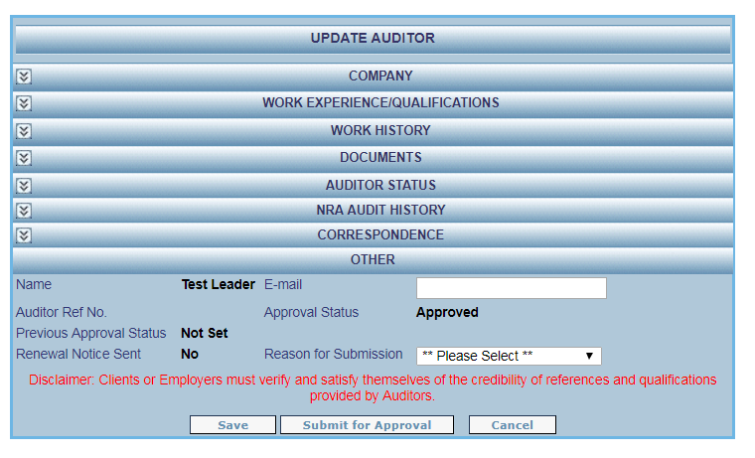

If any difficulties are encountered the RSAAS team can be contacted on Roadsafetyaudits@TII.ie

