Submitting a road safety audit team for approval
on TII Road Safety Audit Approvals System (RSAAS) website https://web.nra.ie/safetyaudits/
Audit Approval is submitted by the Client. This is usually the project manager for a scheme, but could be any individual acting for Local Authorities, Engineering Consultants, Architects, Developers or individual householders.
It is necessary to register as a client before submitting an audit. See RSAAS Registering Guidance.
Creating an Audit:-
Scheme: Enter the name of the road scheme for which the audit is required. Scheme names for certain TII funded schemes are already entered and can be picked from a dropdown list.
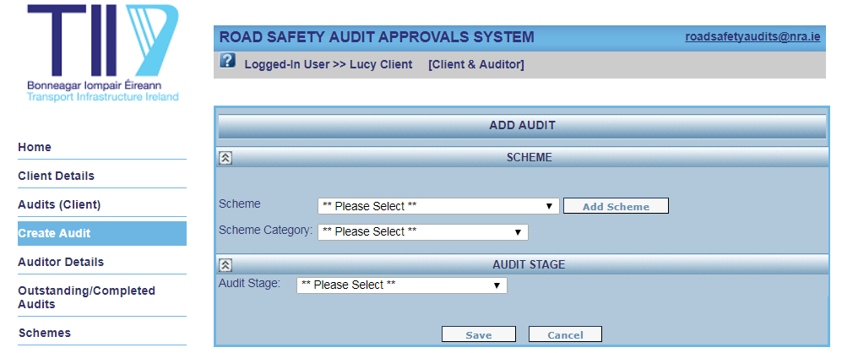

If your scheme is not on the list it can be added using the “Add Scheme” button. It is essential that ALL relevant details requested are completed.
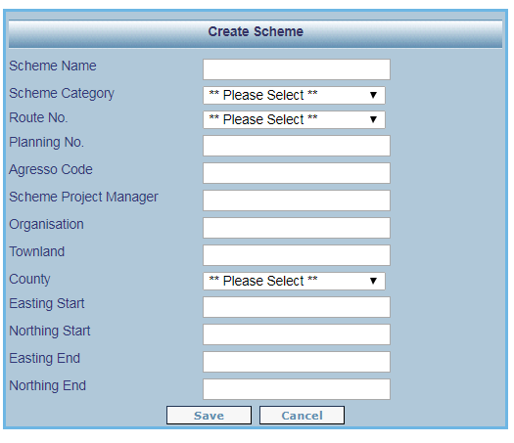

Scheme Name should readily identify the works and its location. If the scheme is associated with a proposed development the name should include the name of the development, the type of development, the townland name, and the form of junction or road link proposed.
Scheme Category must be picked from a dropdown list. It is important that the correct type is chosen, so an appropriately experienced audit Team Leader can be approved.
Route Number should be picked from a dropdown list.
Planning Number should be entered if the scheme is associated with a proposed development.
Agresso Code should be entered if the scheme is funded by a local authority.
Scheme Project Manager’s name must be entered. In the case of a scheme associated with a proposed development this is the name of the developer or the householder.
Organisation is the company or local authority or, in the case of a scheme associated with a proposed development, the development company.
County must be picked from a dropdown list.
The scheme location must be entered using Easting and Northing Start co-ordinates. If the scheme includes a length of road then End co-ordinates must also be entered.

Audit Stage: This can be picked from a dropdown list.
If approval is needed for more than one stage, then this should be done using two separate submissions.
The combined stage 1 & 2 refers to one audit which covers both stages, and should be used only on smaller schemes. In this case there will be only one design stage audit before construction and it is thus necessary that the level of detail in design submitted for this audit is the same as that expected for a stage 2 audit.
Save the audit before going on to enter the names of the audit team members.
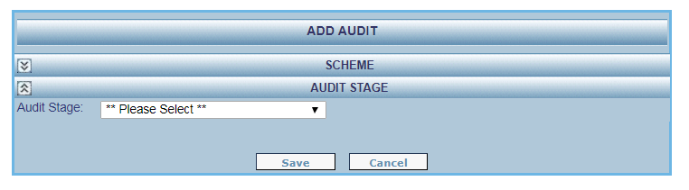

Entering the Audit Team:-
Find by Ref. no: Enter the Auditor Reference Number of each of the proposed team members. For each auditor select the “Find” button.
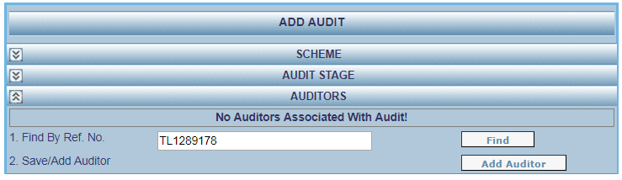

When the name of the auditor appears select the “Add Auditor” button.
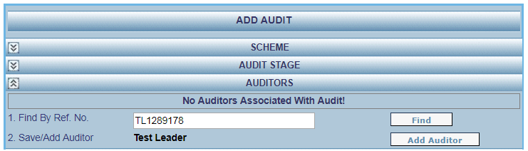

There is a limit of 4 auditors per Road Safety Audit Team.

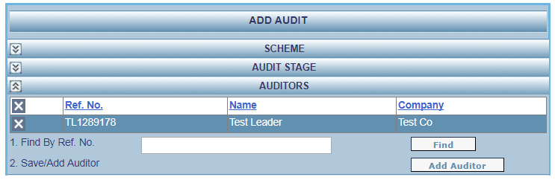

Submit For Approval: Once all individuals proposed for the Road Safety Audit Team are entered select the “Submit for Approval” button.
If the proposed individuals do not make up a qualified team, i.e. if none of the proposed auditors is qualified as a Team Leader for the Scheme Category in question, then the submission will be automatically denied.
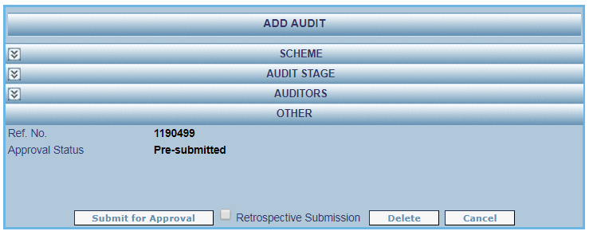

If any difficulties are encountered the RSAAS team can be contacted on Roadsafetyaudits@TII.ie

